How to Make a Cake Decorating Bag
Cake decorating often includes writing, flowers, and other designs on the top of a baked and frosted cake. It takes practice to become good at creating a professional look. If you plan to decorate cakes frequently, you can save money by making cake decorating bags out of parchment paper. You make a cone, place icing inside and pipe it through the end of the cone. After some practice, you should be able to create a versatile decorating tool in a matter of minutes. You can then dispose of it and start anew with another parchment decorating bag that holds a different icing color or piping size. Learn how to make a cake decorating bag.
Steps
1 Find a flat surface, such as a large, clean cutting board, to work on. You can use the decorating bag immediately after making it, so keep your frosting nearby.
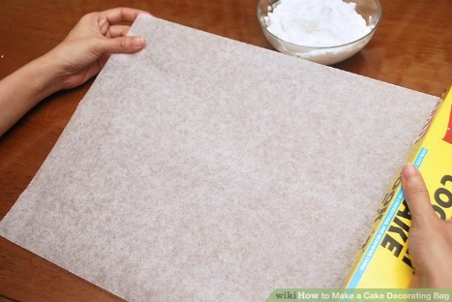
2 Tear a large, rectangular piece of parchment (baking) paper off the roll. There is no specific size that it must be, but you should aim to have a piece that is approximately 12 inches (30.5 cm) high by 14 to 18 inches (35.6 to 45.7 cm) long.
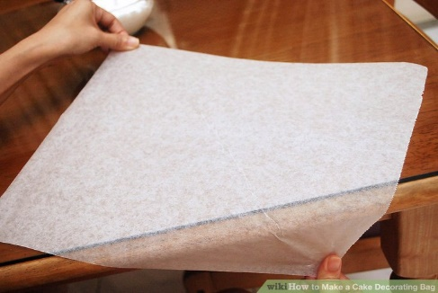

3 Notice how the parchment paper rolls up on its own, if you tore if off a roll. Take an end of the parchment paper in each hand, with the outside of the roll down. Roll it back and forth against the edge of a clean counter, to make it as flat as possible.
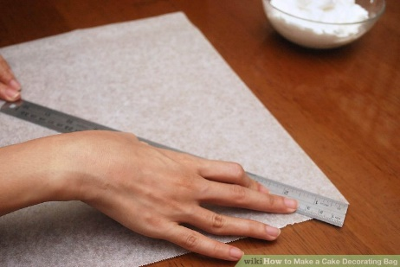

4 Place a long, clean straight edge from the top right corner to the lower left corner. Place your hand down on the straight edge to steady it.
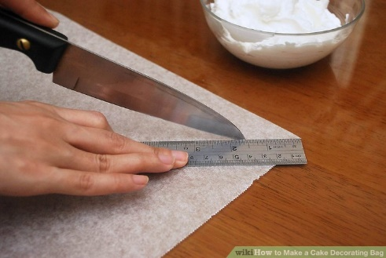

5 Take a sharp knife and cut across the paper, next to the straight edge. You should have 2 obtuse triangles when you are finished. Place 1 triangle aside, to make another cake decorating bag in the future.
  - You can also fold the parchment paper down from a rectangle into a square by moving the upper left corner to the bottom right portion of the paper. Cut off the excess paper at the right end and then cut at the fold. Although this may feel more exact, it can cause slight problems and gaping in the decorating bag, where the fold was pressed and cut.
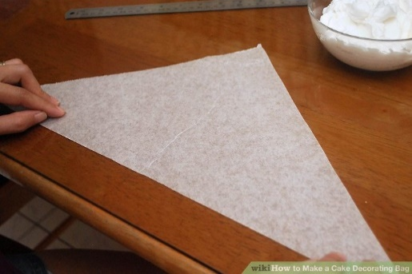

6Place the longest part of the triangle near you on the cutting board. Take the right corner of the triangle and curve it up to meet the top, or apex, of the triangle. You will need to make a cone shape, with the tip pointing toward you.
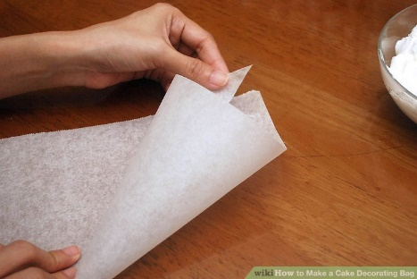

7 Hold the right corner and the apex together with your left hand. Take the left corner and wrap it over the cone to the right, until it reaches the back and top of the triangle.
  - Make sure the cone forms a closed tip at the end.

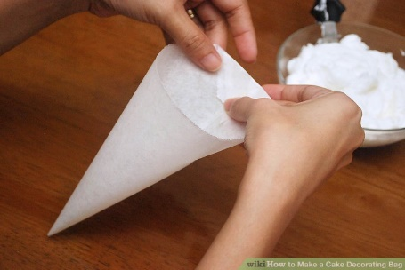

8 Hold both of the corners together at top back of the cone. Fold them down toward the inside of the bag. Staple it in place, if it does not seem to be holding together on its own.
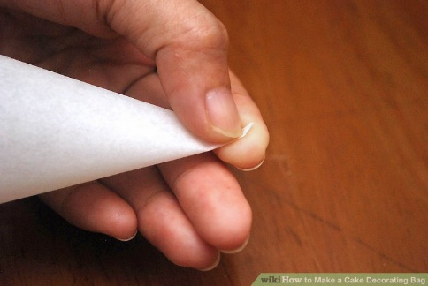

9 Fold the tip of the cone at the very end, if you do not plan to use a metal or plastic decorating tip. If you do want to use a scalloped, flower or other decorating tip, snip the end of the bag very slightly and push a decorating tip into the bottom of the cone.
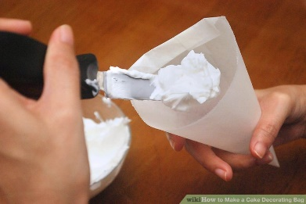

10 Use a spoon or spatula to scoop up frosting or chocolate. Allow the frosting to drip into the center of the cone. Fill the bag a third full with icing.
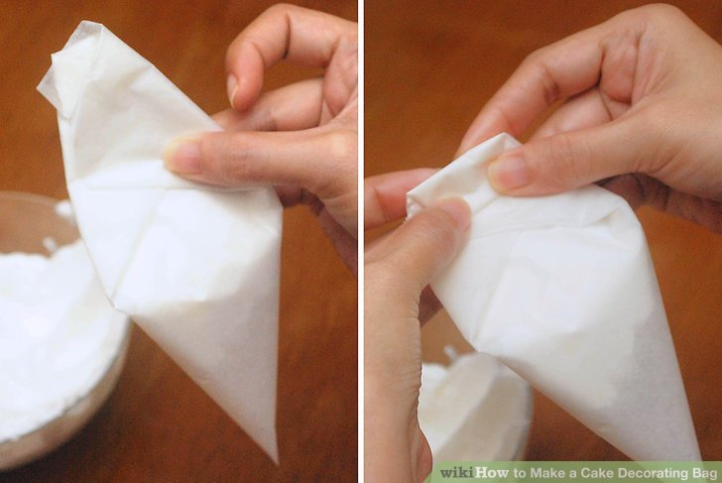
11 Fold the sides at the top of the icing bag toward the center. Begin to fold the top down like a toothpaste tube. This will push the icing down into the bottom of the tube.
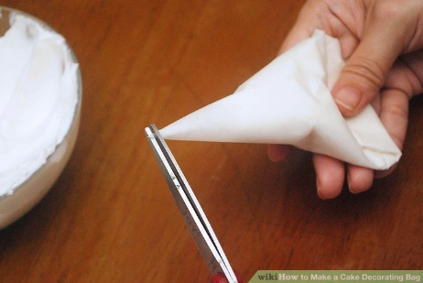

12 Snip the bottom of the bag evenly with kitchen shears, if you are not using a cake decorating tip. Make sure to start small. You can always take off more, if you want a larger icing stream.
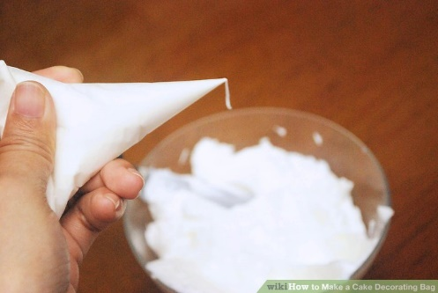

13 Press on the top fold of the icing bag to dispense the frosting from the bottom. Continue to fold the pastry bag down as the bag starts to empty. It will ensure extra icing doesn't come out of the top.

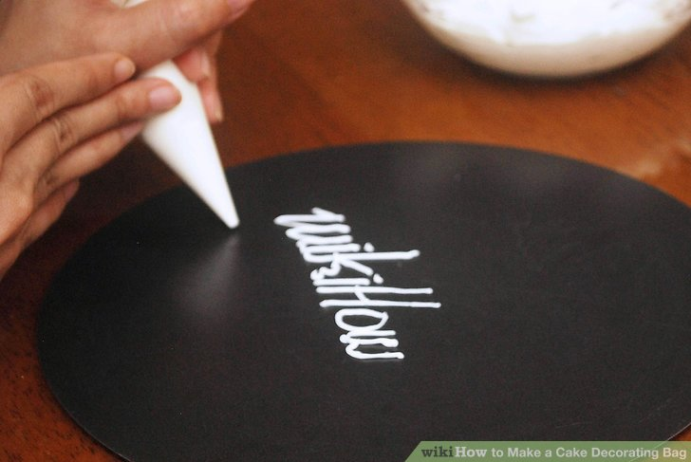

14 Practice piping the icing onto a plate or another piece of parchment paper. You can create shapes, writing and intricate decorations with practice.

