Selecting and Purchasing a Dutch Oven:
New, the cast iron Dutch oven can be very costly. If you check junk shops, rummage sales, or thrift stores you might be able to save yourself a lot of money. However, make sure you are getting a good quality Dutch oven.

If buying a used Dutch oven here are a few things to look for:
- Cracks, chips, casting imperfections and rust spots
- Examine the pot and lid both inside and out
- Make sure the lid fits properly
- Make sure there is no rocking motion when the lid is on the pot
- Make sure the lid does not fit too tightly on the pot
- Check the wire bail for strength and that it moves easily
- If looking for a camping pot, then only buy a Dutch oven with legs and determine that these are in good condition
- Check the thickness of the metal – inconsistencies will mean inconsistencies when cooking
- Make sure there is a loop handle which makes it easier to pick up with a hook
- Avoid Dutch Ovens with riveted tabs

Type of Dutch Ovens:
Standing in the aisle with Dutch ovens you are likely to be bombarded with choices. Do you get aluminum or cast iron? What is the difference between a kitchen or camp oven? Where do bean pots fit in? Should you get a pre-seasoned pot or not?

Aluminum Dutch Ovens – Most traditionalists will tell you that cast iron is the way to go, but there are advantages to both aluminum and cast iron. Aluminum is a light weight alternative for those hiking in to their campsite or for cooks with physical limitations. For a 12-inch pan, aluminum pans weigh about 7 pounds rather than the 18 pounds for a cast iron pot. Aluminum is also easier to care for as it won’t rust and can just be washed as any other pan is washed in soap and water. It also doesn’t require seasoning like a cast iron pan. Some of the newer models even come with a non-stick surface. Aluminum will not discolor the food like cast iron does. It also heats faster; however, there are also two disadvantages to this. On windy days the pan will have more fluctuations than cast iron and if you get an aluminum pan too hot, it will melt. Two areas aluminum excels at are baking bread and making gravy.

Cast-Iron Dutch Oven – While some of the newer aluminum pans come close to cast iron, cast iron is still the preferred material for a Dutch oven. Good quality cast iron can be passed down through generations because the material is so long lasting. A cast iron pot distributes the heat evenly and less heat is needed to cook the food. It will also retain heat longer, often a pan can be removed from the heat before the food is done cooking and the heat retained in the pan will finish the cooking process. Since the cast iron will retain heat, there is less fuel needed for cooking. The heavy lid seals the pot and steams the food, which keeps it moist and tender. Unlike the aluminum pan, cast iron tolerates the higher temperatures better and is not likely to melt. It reacts more slowly to the heat changes so is less affected by windy weather. Food can sit in a closed cast iron oven for longer and retain the heat needed for serving. Since the cast iron Dutch oven cools slowly, if food has to be a certain temperature then remove it from the oven. There is the added benefit that cooking in a cast iron pan adds iron to the food cooked in it. Dutch ovens come with a variety of stove names. Camp, outdoor, kitchen, or bean pots are the most common names. As you are standing in the aisle at the store, don’t let all the names confuse you. First camp or outdoor Dutch oven are the same type of oven. Likewise the bean pot or kitchen Dutch oven are the same, they have no legs.

Camp or outdoor Dutch ovens have the following features:

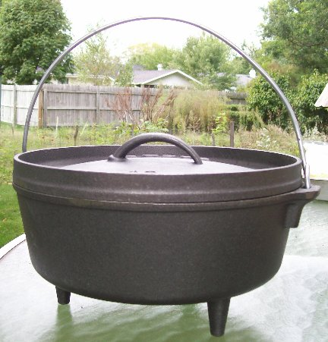
- The camp or outdoor cast iron Dutch oven is the preferred oven for outdoor and campfire cooking.
- Flat bottom
- Three short legs which allows the oven to be above the ground to allow the circulation of air onto the coals.
- Strong wire handle which may have the option to stand up at a 45 degree angle. By having the handle stand up it will give better access when positioning or removing the oven from the fire.
- Flat lid with a lip of 1 to 2 inches; the lip allows you to place hot coals on top of the oven1 or can be used as a frying pan.
- Small loop handle on lid, make sure it is attached at both ends to make it easier to lift off with a hook.
- Skillet type handle attached to the lid which helps when using the lid as a griddle or fry pan.
- Size of ovens range from 5 to 22 inches in diameter for the rim. Depth is around 3 inches but some can be as deep as 9 inches with the larger diameters. Remember that the larger the oven the heavier it will be when it is full of food. A 12-inch Dutch oven full of food can weigh as much as 25 pounds.

Kitchen, stove, or bean pots have these features:


- Flat bottom with no legs which are good for using on wood burning stoves.
- Lid may be domed or have spiked nodes for basting
Generally, the kitchen (stove/bean pot) version of the Dutch oven works best on the stove at home, on a propane burner, or hanging from a tripod. However, if you have a couple of bricks, you can place the oven on them and coals underneath.

