Guide to the Leather Working Tools You Need:

Leatherworking is an exciting craft to get into. You might be curious about what tools you’ll need for different projects or even styles of leather craft. Let’s take a look into all of the leather working tools.
When starting leather craft as a beginner or even with experience, the leather working tools you’ll need can include awls, bevelers, burnishers, cutters, gouges, glues, groovers, mauls, pricking irons, punches, skivers, stamps, sewing items, and a cutting mat. Specifics will depend on the project.

Leather Working Tools
There are many leatherworking tools available. Some are very specialized, and others are general. Some are only used for unique styles of leatherworking, while others are helpful for any type.
The great reality of leather working, though, is that it can be started with relatively few tools. This is excellent as you can get a feel for the craft without building out an entire workshop. It also means one can get started without spending much money or investing significant resources early on.

Leather Working Awls 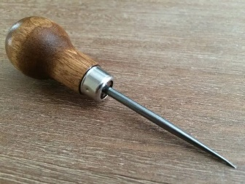
Awls are tools with a sharp metal point used for marking or piercing leather. They can be used to impress a small mark, such as where belt holes will go, or even dragged across leather to leave a mark, such as when tracing pattern templates.
Some leather awls come fixed with a single point, others allow points to be interchanged. Points include rounded and diamond-shaped, where the diamond shape cuts the leather so that it is easier to stitch through and leaves a hole in the leather that can sit flatter once punched.
Awls are relatively versatile tools for leather working; it’s common to have more than one overtime.

Leather Working Burnisher & Slicker Tools 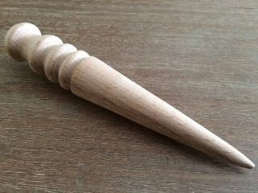
Leather burnishers and slickers are usually rounded or curved tools used to burnish (smooth out) leather surfaces and edges through friction. Since leather is a natural fiber that has been processed to have a smooth and even finish, when it’s cut, the edges will show the internal fibers and often be loose or “hairy” as the fibers stick out.
Smoothing out or burnishing the edges helps ensure a finished leather product that can wear well and be durable. This hardens and strengthens the edges. Sometimes, edges are even painted to seal them up. Many preferences and options are available for this, though burnishers and slickers are often used.
They come in different materials ranging from plastics to exotic woods. There are hand burnishers, where you move it back and forth over the leather by hand it generates heat through friction and changes the leather surface.
Burnishing tools that use motors to rapidly move the burnisher over the leather to seal the edge are also available. Burnishing machines and attachments make this a very easy task and include dedicated machines and attachments that fit onto drills and rotary tools.
The key to burnishing is heat generation and transfer. When the edge leather fibers are heated, they join together and smooth out. So, friction created by moving a burnisher back and forth quickly makes this happen. When choosing a leather burnisher, keep in mind the different heat properties of the material.

Water Spray Bottle
Sometimes, it helps to burnish when the leather or leather edge is wet first. Not too wet and soaked, but just enough to aid in the heating and smoothing process the burnishers do. A common water spray bottle can be great here as a leather working tool, allowing the crafter to mist the leather areas just a little and then get to burnishing.
They don’t spill easily, and some have an adjustable spray nozzle, so you can choose how much water comes on in the mist. This is a simple but convenient way to wet leather that is to be burnished.

Leather Working Cleaning & Conditioning 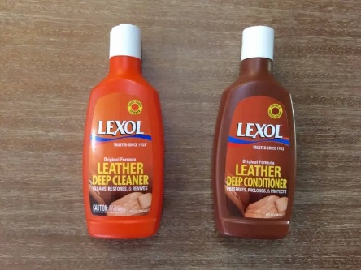
Leather is a natural material and can last for centuries if it is well cared for. That usually involves periodic cleaning and conditioning to ensure that it stays in top shape during everyday use.
Leather needs to maintain a healthy balance of humidity and oils. If it gets too dry, it can become brittle, flake, and crack apart. If it gets too wet, it can begin to mold and decompose. It very much likes the middle ground of just enough moisture and oil to be a supple, strong, and lasting material.

Leather Cleaner
Choosing a leather cleaner is highly dependent on the type of leather being cleaned. There are specialized leather cleaners and more general ones that are safe for many types of leather. The cleaner helps to loosen and remove dust, dirt, debris, and grime from the leather surface. This ensures that when you apply the conditioner, it does not trap any dirt and instead goes right into the leather where it needs to be.
Be sure to check that the leather cleaner you might use is safe for your type of leather. Also, always try it on a small, out-of-sight place first to test for any potential adverse reactions or issues with the cleaner and the specific piece of leather you’re using it on.

Leather Conditioner
After cleaning, applying leather conditioner helps to rehydrate the leather and restore moisture and oils that are essential to its maintenance.
Some leather conditioners also leave a protective finish over the leather, further helping it resist picking up too much water, dirt, and debris before the next time it is cleaned and conditioned. When well-cared for, leather can last and be usable for generations.

Leather Oil
Leather oil is a type of leather conditioner. There are many different types and formulations available. Some cater to specific leather products (shoes, boots, bags, etc.), others to the conditions the leather will be used in, and even others have more general formulations that work well on most leathers.
Leather oils can be just oils or combinations of oils, waxes, and other natural and/or synthetic ingredients aimed at conditioning and protecting the leather. Definitely read up on the particular leather oil you might choose, reviews of its performance, and how well it will work for your specific leather application. With the right oil/conditioning, the leather will look and feel amazing.

Leather Working Creaser/Folder Tools 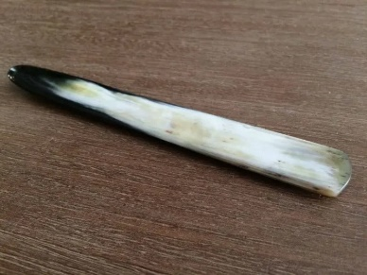
Leather creasers help put a crease in the edge of leather, often for aesthetic reasons. They can also be used for functional reasons when folding/shaping leather goods or putting an edge onto fine leatherwork.
For projects where thick leather is being used, and there is a fold line, the creaser/folder can be used to prepare the line on which the fold will bend. This avoids stretching the leather near the bend, making it much cleaner and visually appealing.

Leather Working Knives and Bladed Tools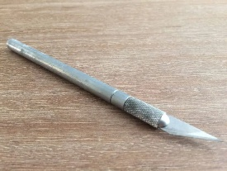
So very common in leather craft is cutting leather. In most things you’ll work on, cutting will be some part of the process or design. As such, getting familiar with the different types of cutting and bladed leather tools will be helpful.
They include knives (such as utility & crafting knives) in many varieties, shapes, and sizes. Rotary cutters are rounded blades mounted as a wheel, scissors for rougher cutting, and strap cutters for cutting long leather straps and laces. Each type has various configurations, sizes, and qualities to fit your needs.
With all knives and bladed tools, proper maintenance is important. Leather can be a tough material, knives with sharp, well-cared-for blades will make the work much easier. and the end result will be much cleaner and more professional-looking. Now, on to the fun stuff and all the info! 🙂

Cut-Resistant Gloves
Cut-resistant gloves help protect the wearer’s hand from cuts when working with or around sharp knives. The level of cut resistance can vary based on the materials, methods of manufacture, and intended level of protection.
They would be a recommended addition to your leather working tool kit, where both hands or one can be used whenever appropriate. For example, if the right hand is holding a cutting knife and the left is holding the leather, maybe wear a cut-resistant glove on the left hand, as that will be nearer the cutting blade.
Leather crafters have survived for centuries without them, and they’re not an absolute need. However, it’s always helpful to be protected if reasonable, and in some cases, these can help.

Leather Scissors
Scissors usually have symmetrically sized finger holes and are shorter than 6” in length. They can be held in the air while cutting or rested on the cutting surface while making the cut. Leather cutting scissors are usually made with strong, sharp blades that can smoothly handle thinner and thicker leathers. Choosing the right leather scissors can greatly enhance the precision and ease of your cutting tasks, ensuring clean edges and reducing hand fatigue during extended use.

Leather Working Dyes, Paints, & Finishes
Leather paints, dyes, and finishes help turn leather into incredible products. From the uncolored hide to the undyed finished leathers, the possibilities are endless when considering your final piece.
Leather dyes are pigments used to change the overall color of leather. Leather paints are generally used as accent colors on locations such as edges. Finishes can range from visually appealing to transparent and protective, helping the leather wear well and last longer.

Wool Daubers
Wool daubers are little balls of wool attached to a wire handle. The balls are approximately 1/2” – 1” wide, and the wire handle is about 5” long. Daubers are great for dipping into leather dyes and finishes and then rubbing onto the leather surface to apply the dye or finish.
The wool picks up an amount of dye or finish depending on how deeply it is dipped. It then offers some control over where the dye or finish is placed on the leather piece and how evenly it is applied. For smaller leather pieces, daubers are a great choice as applicators.

Leather Working Edger & Beveler Tools 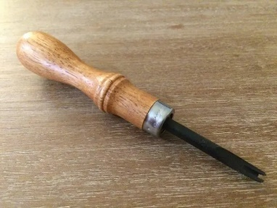
Edgers and bevelers are tools used to shave the square edges off of leather. This is done for both functional and aesthetic purposes. Functionally, it removes the sharper square edges and leaves a more rounded edge on the leather. This makes it less likely to catch on to other items during daily use. The rounded edges are also more comfortable on items that are handled frequently, such as belts and wallets.
Aesthetically, the rounded edges on leather are generally more pleasing to the eye. They soften the look and make it easier to seal the edges when burnished or edge-painted.
Edgers and burnishers come in many different shapes, sizes, and styles. They are usually made with metal blades/tips attached to a wooden handle. One thing to keep in mind is that not all edgers are sized the same way. A particular size from one brand or manufacturer might not match that from another manufacturer.

Leather Working Finishing Tools 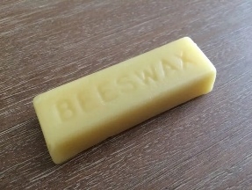
Leather finishing tools are used primarily to refine the edges of leather work. When cut, the natural fibers inside the leather are exposed. They might show as loose or “hairy” as the fibers stick out. This is generally unpleasing to the eye and exposes the leather to faster wear and damage from moisture.
Leather finishing tools help finish the edges by smoothening and sealing the fibers. This strengthens the edges, protects the leather, and makes them more visually appealing. Leather can be finished using a combination of abrasion/friction and waxes/sealers.

Sandpaper/Sanding Blocks
Sandpaper can be used to smoothen the edges of newly cut leather. The roughness of the sandpaper wears down the loose fibers, shortening them and creating a more dense, smoother surface.
This is usually achieved by using coarser sandpapers that are rougher and working down to finer sandpapers that leave a tighter edge. Sandpaper is available in many variations, most commonly grit size. Grit size refers to the size of sand grains on the paper. Coarser grits have a lower number (for example, 50), while finer grits have a higher number (for example, 120).
Sanding blocks are blocks of material, usually wood or plastic, with sandpaper attached. When attached to something that fits well into the hand, it can be easier to hold and rub across the leather. Sandpaper is relatively inexpensive and quite useful for leather finishing.

Leather Working Glues & Adhesives
While leathers are typically joined via methods including sewing or riveting, sometimes it can be helpful to first secure the surfaces with glue or adhesive. Once in position, it makes it easier to do the sewing, riveting, etc.
There are many different types of leather glue adhesives available that work well with leather. Some are temporary, with a tacky result that can be easily moved and reapplied. Others are stronger and more difficult to remove. Some glues expand into the materials as they dry. And yet others are extremely strong and considered permanent. For very strong glues, they bind so tightly that trying to remove the adjoined pieces will likely damage the leather.
Wool daubers can help apply and smooth out leather glues. It’s important to know the preferred end result. If you plan to remove stitching later and separate leather pieces, consider using a less strong or temporary adhesive to make this easier. Glues are available with different drying times and some variation in colors.

Leathercraft Cement
Leathercraft cement is an adhesive specifically made for leather craft use. It helps make strong bonds in an easy-to-use formula. The positives are that it is generally non-toxic, non-flammable, and dries relatively quickly. This is worth keeping in mind as some adhesives can be toxic to breathe in, requiring proper ventilation when working. Leathercraft cement can be useful across leather types and project needs.

Leather Working Metal Roller
Leather working metal rollers are used to smooth out layers of leather that are glued together. Since leather can be thick, and also usually has a nicely finished, smooth surface, a special tool is helpful here.
The metal roller is comprised of a solid, heavy metal cylinder attached to a handle. When pushed or pulled, the roller rolls over the leather, applying pressure and helping ensure a tight adhesion between leather layers. Bubbles and air gaps are removed, resulting in a nicely-finished and fine-looking result.

Leather Working Gouge Tools
Leather gouges are used to remove a bit of the leather material so that the leather can fold or bend in a preferred direction. Since when leather bends, the fibers stretch, removing some of the material at the bend point allows the leather to fold more naturally, creating a visually appealing and functionally helpful element to the design. Leather gouges come in a few different shapes.

Leather Working Groover Tools 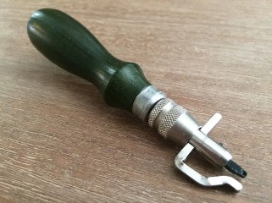
Leather groovers are tools used to cut grooves into leather. Grooves can be used just for marking lines. For example, pulling the groover with light pressure will cut a light line into the leather. Grooves can also be cut deeper, creating a channel in which stitching can be set. Since the final stitched will rest within the groove below the surface of the leather, they will be less susceptible to abrasions and tearing.

One can also place grooves where they want to create a fold line in the leather material. Or, cut grooves into leather for decorative purposes. For example, adding a groove along either side of a belt. Groovers are generally available as stitching or scratch groovers, each with its potential benefits.

Leather Working Hardware Fasteners & Setter Tools 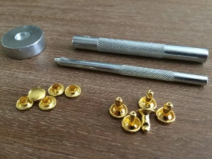
Leather hardware and fasteners join pieces of leather together. The joining can be temporary or more permanent depending on the hardware used.
Leather hardware not only serves functional purposes but also enhances the overall design and durability of leather goods. Fasteners can be made of many different types of material. Mostly, they are steel, brass, nickel, and copper. Commonly, you’ll see rivets, snaps, and grommets. Each has its own main purpose, while they also have variations in aesthetic and cantonal appeal.

Application of fasteners can be done manually with just a few general tools, manually with specialized tools, or mechanically using setting and pressing machines.

Leather Working Holding Tools
Leather holding tools hold leather while it is being worked on. For example, one might want to use pliers to hold a leather piece while burnishing it or applying edge paint. They might also be helpful to hold things while stitching or making a specialized cut. Others hold glued leather pieces securely in place while the leather glue dries. While not primary leather working tools, tools that hold leather can be helpful occasionally for various needs.
It’s important to remember that any leather clamp, pliers, or holding tools that come into contact with the leather should have a soft surface. If not, uneven surfaces on the clamp or pliers could deform, cut, or mar the leather. Some clamp or plier jaws are coated with leather, making them perfect for leather-on-leather contact during holding activities.

Leather Working Marking Tools 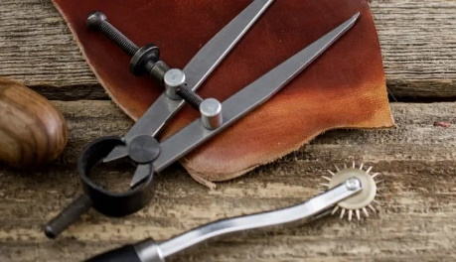
Much of leather work revolves around cutting and shaping leather into an amazing final design. To accomplish that, leather marking tools are extremely helpful. They allow us to put marks onto the leather, some temporary and some permanent, that can be useful guides as we cut, trim, punch, and sew.
Across the types of tools, we’ll see some for scratching, some for pricking and stippling, some for straight lines, some for curved lines, and others for corners. The correct or most helpful marking tool can benefit almost any leather marking need you might have.

Leather Working Corner Tool
A leather corner tool is a stencil guide used to mark off corners and small curves on leather material. Often made of plastic, they are helpful in marking off curved areas. If thick enough, they can even be used as a cutting guide right on top of the leather. The knife can carefully trace the curve, ensuring a geometrically accurate and clean, smooth, curved cut.

Leather Stippler
A leather stippler is a tool used mainly for leather carving. It usually has a wooden handle and a metal end with several pointed tips that generally form a circular pattern. When pressed into the leather, the tips leave a pointed pattern in the material. Pressing can continue, offering a way to add texture to the background of leather carving work. If you are looking to add that stippled/pointed look and feel to a carved piece, the leather stippler can be a helpful leather working tool for the kit.

Leather Working Mauls, Mallets, & Hammers
Mauls, mallets, and hammers are used for a variety of impact tasks during leather work. The choice of which to use is driven by a combination of use and personal preference. Generally, mauls work well for punching and tooling. Mallets can be used with tooling and punching. Hammers work well for forming leather, especially in show making and saddlery.
When choosing a leather maul, mallet, or hammer, it’s important to consider how they’ll be used most. The biggest factor in selection is the combination of surfaces — the hitting surface and the surface being hit.
For example, hitting a metal punch with a metal hammer can damage both the hammer and punch. So, for this, a nylon maul or a natural hide mallet (both softer surfaces than metal) would work.

Leather Working Measuring Tools
When working with leather, measuring tools are so helpful in marking everything from cut lines to punch and pricking marks. They’re even used when laying out intricate and decorative designs in leather carving.
Measuring tools come in a wide variety of options, shapes, sizes, and configurations for both general and specialized uses.

Leather Working Molders
Leather working molders are metal tools that assist in the molding of leather. They’re generally a handle (either wooden or metal) with a solid metal end that comes out. The metal end is rounded, allowing it to fit into, under, and around many areas. They can provide supportive pressure that holds leather in place when it is being hammered or shaped when molding leather in either the wet or dry methods.

Leather Working Pricking Irons
Leather working pricking irons are metal tools with a grouping of equally-spaced “teeth”, sharp points arranged in a line. They are used to mark the location of stitching holes in leather material. Since leather is a generally thick material, holes need to be pre-made for the needle and threads or laces to go through. The holes can then be made using awls or chisels.
Pricking irons are made with a set distance between points to ensure the hole marks are uniform and consistent. This allows for tight seams and a clean visual appearance on the completed leather piece. Pricking irons are usually only intended for marking leather, not pushing holes through it.
While a pricking iron might push into the leather, leather chisels are more functional and intended for making the actual holes that pricking irons are used to mark off. Leather pricking irons come in variations of tooth counts, commonly ranging from one to twelve. This allows the leather crafter to choose which will be most helpful.
For example, when pricking a length of leather in a straight line, more teeth will help accomplish this faster. When pricking a curved end in a leather piece, fewer teeth will be more helpful as they allow the crafter to follow the curve of the edge prick by prick.

Leather Working Chisels 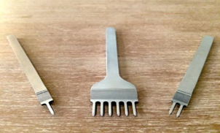
Leather working chisels are metal tools with a grouping of equally-spaced sharp “teeth”, sharp points arranged in a line. They are similar in look to pricking irons, though chisels are intended to make the holes in leather, whereas pricking irons are intended only to mark the holes in leather.
Leather chisels come in variations of tooth counts, commonly ranging from one to twelve. This allows the leather crafter to choose which will be most helpful. For example, when chiseling a length of leather in a straight line, more teeth will help accomplish this faster. When chiseling a curved end in a leather piece, fewer teeth will be more helpful as it allows the crafter to follow the curve of the edge, hole by hole.

Leather Working Punches Tools 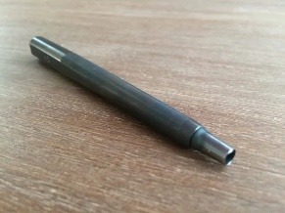
Leather punches are tools with rounded blades used to cut holes into leather. Generally, the blades have sharpened edges around a hollow metal cylinder, perfect for creating a circular hole. The punch blades can be interchangeable, allowing a single handle to accommodate many sizes. Or, they can be individual tools where the blade and handle are formed from a solid piece of metal.
Punches need to be strong as they are used by pounding them with force. A piece of leather to be punched is placed on a nylon surface on top of a hard, sturdy surface (such as granite). The punch lines up and rests on the leather, where it will make the hole. Then, a mallet, hammer, or maul is used to strike the top of the punch.
The force of the strike pushes the punch through the material. The softer nylon surface protects the punch blade from damage, and the granite absorbs much of the force. The result is a smooth, clean hole punched into the leather.
Leather punches come in a very wide variety of shapes and sizes for many different uses. It is also important to maintain the blades well, as a sharp blade will produce superior punching results.

Leather Working Sewing Tools 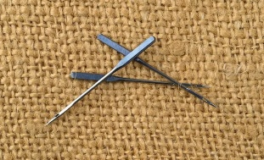
Leather sewing tools are comprised of a wide range of items used for stitching leather. They generally include needles, thread, sewing machines, and tools to hold leather while you sew. Within these groups, many options are available that fit across needs, styles, and preferences.
While leather can be joined by hardware such as rivets and grommets, sewing provides a wealth of functional and aesthetic means of joining leather material together. Leather sewing tools are used to make endless leather goods, including wallets, bags, belts, clothing, and shoes.

Leather Working Thread 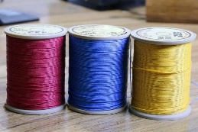
Leather sewing thread is a thin yarn used to join leather materials together. Threads are very common leather working tools and come in endless colors. They also come in various “weights” or thicknesses, each with benefits depending on the type of leather being sewn.
Generally, thinner leathers will use lighter “weight”, thinner threads. Thicker leathers are usually sewn with thicker or heavier “weight” threads. Leather thread weight choice can be a matter of function. For example, is it strong enough to hold the materials together and not wear out easily from rubbing or abrasions? Thread can also be selected based on aesthetic preference. For example, does the color look great on the leather it is used with? Does the seam size create a nice, finished visual appearance?
Along with colors and wights, threads are also available in many different material types. So much thread! 🙂 Each material type has unique properties that can benefit some types of leather work over others. Let’s explore a little more about each and which you might want to add to your leather craft tools list.

Leather Working Skivers Tools 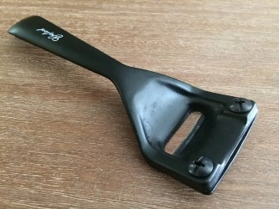
Skivers are tools used to remove thin layers of leather material. They generally have a very sharp cutting blade. When the blade is drawn against the leather grain with some pressure applied down upon it, the blade cuts through the leather as it moves along, shaving off a thin layer.
A leather skiver is helpful in many facets of leather work. It is used, for example, when making belts. At the point where the leather is folded over to secure the buckle, there would be double the leather thickness since the material is folded over. This could be bulkier than necessary, as well as potentially uncomfortable to wear. Skiving can be used to thin out the leather on both sides around the fold so that when they are joined together, it is only about one layer thick. This will look cleaner and wear more comfortably.
This same process can be applied to bag straps, saddlery, and any leather work that involves folding and joining thin leather pieces. Leather skivers are available in hand-held versions, manually drawn against the leather, and tabletop versions, where the leather is pulled through the skiver.
Additionally, skiving knives are used to free-hand skive. Carefully removing leather layers is part art and part skill. Most leather craftsmen will, at some point, have one or several skivers on their list of leather craft tools.

Leather Working Splitters Tools
Leather splitters are tools used to uniformly remove a thickness of leather material. They can split leather evenly or by a preferred and set thickness. They are comprised of strong, metal blades generally 6”-8” wide.
Once the thickness of the cut has been set (via an adjustment mechanism), the leather is placed into the splitter, secured by lowering a level, and then pulled through. It is split as it is pulled through. This produces clean and consistent results very quickly.
The thickness of the split can also be manually adjusted by pushing or pulling on the lever as the leather is being pulled through. This allows for variable thicknesses to be split, for example, towards the ends of a belt. A leather splitter can be a very useful tool for a leather craftsman who produces higher-volume work that requires consistent adjustments to leather thicknesses.

Leather Working Stamps Tools 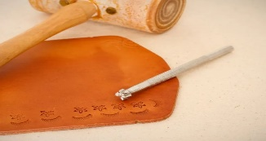
Leather stamps are metal tools used to imprint decorative designs into leather. They generally have etched designs on the end of a solid metal handle. When rested on the leather and struck with a hammer, mallet, or maul, the force pushes the stamp into the leather material, leaving an imprint in the leather of the design that was etched onto the stamp.
Leather stamping is an extensively used craft in leather tooling. Stamps are available in a tremendous variety of shapes, sizes, letters, numbers, and designs. Since stamps only require striking force, they are a very quick way to add visual embellishments to leather work. Carving the same designs by hand could take hours, with sometimes less-than-desirable results.
Stamps are available individually or in sets. In this area of leather craft, the imagination can really run wild with options for using and combining stamps to create a decoratively finished piece.

Leather Working Tooling, Etching, & Engraving Tools
Leather tooling, etching, and engraving are styles of leather working that involve altering the surface of leather material for visual and aesthetic enjoyment. Some of this work requires tremendous skill and practice to do well.
Leather tooling is the practice of imprinting designs into leather, usually with metal stamps. The stamps available cover a nearly endless amount of designs, shapes, sizes, letters, and numbers.
Leather etching, which can also involve leather engraving, is the practice of cutting into the leather’s surface to produce intricate or decorative patterns. This usually involves using specialized knives as the crafting tool for this impressive style of leather work.

Leather Tooling Stylus
A leather tooling stylus is a metal tool with a rounded tip used for tracking patterns into leather for tooling. When a leather crafter has a design in mind and is sketched onto leather tracing paper, they can transfer that outline to the leather by pressing into it with the rounded end of a tooling stylus.
The pressure applied to the stylus pushes the tracing paper, leaving a colored mark/line on the leather’s surface. The lines traced with the stylus serve as a guide for the next step in the tooling process. They are handy tools for leather tooling work.

Leather Tracing Film
Leather tracing film is used to help transfer a pencil-sketched design onto leather. The original design, possibly sketched onto a piece of ordinary paper, can be traced onto the tracing film. When transferring the design to leather, the leather is moistened, and then the tracing film with the design is laid over it.
Finally, a leather tooling stylus is used to trace of the tracing film, which transfers an outline of the design pressed into it by the tooling stylus. This is quite a helpful tool for transferring sketches and artwork to leather.

Leather Working Tools Maintenance
Leather tool maintenance is key to ensuring a quality leather working product. When cutting blades are kept sharp, work surfaces clean, and machines well-maintained, they all perform to their best potential.
While it might seem like an afterthought compared to doing fun projects (which, yes, are more fun than maintenance), maintaining great leather working tools will ultimately help make great work.

Leather Strop 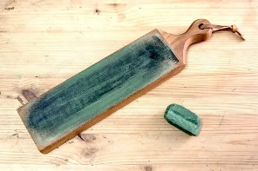
A leather strop is a tool used in sharpening blades. It helps even out any tiny burrs on the blade edge, making it smooth and sharp. When blades get dull, it is generally due to tiny degradations in quality from the sharpened blade. These can include small nicks and burrs on the cutting edge.
When blades are sharpened, they are usually done so by going over the edge with increasingly-fine-grained stones or sharpeners. Coarser sharpening stones are used first to even out larger burrs. Then finer stones are used to reduce smaller burrs. Once the leather strop is used, it’s usually the last and finest-grained tool in the sharpening lineup.
They help produce a smooth edge on the blade while polishing it some as well. When sharpening knives, a leather strop can be a helpful addition to the process.

Leather Working Surfaces 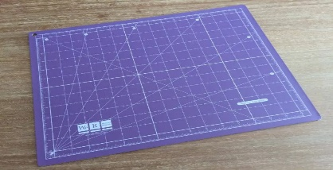
Leather working surfaces encompass the various workspaces and areas used for leather working. They can include tables, mats, stone slabs, and a number of other various materials and surfaces that help when crafting, tooling, or adding hardware to leather.
Leather craft doesn’t require too many surfaces, though there are a few very helpful ones that can make things so much easier. Generally, a sturdy table is essential. This is important as it will need to support the pounding pressure when hitting punches and stamps with a mallet or maul.
A smooth cutting surface, such as a cutting mat, is key. A strong pounding surface helps absorb shock and produce a clean cut. For this, a granite slab can work great. With just a few items, the leather working shop will be set to go.

Anvil
An anvil is a steel or iron tool used mainly as a hitting surface for setting rivets. Most anvils are solid metal, while others can have hollowed-out areas that serve specific purposes. These can include grooves for straightening metal pieces or areas for loose hardware or accessory storage. Anvils commonly sit on top of tables or work benches.

Leather Tool Holder/Stand 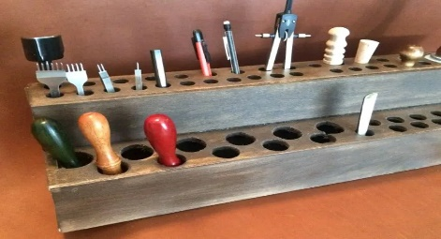
A leather tool holder or stand is a device used to hold and organize leather tools for easy access. They can incorporate a number of holes for placing tools into. The tools stand upright and are easily picked up and put back
The holder can have multiple levels, tiered for access to differently sized tools. It can also incorporate various hole sizes so tools of different thicknesses or diameters have a secure place to be stored. For example, a maul would be much larger in diameter than a small punch.
Some leather tool holders have uniform holes, such as those that store metal stamp sets. Holders are available in different sizes, from small, 12-hole versions to larger, 48+ hole versions.
Leather tools can also be stored in toolboxes or drawers. A stand can be most helpful, as all tools are always visible and within easy reach. Building your own leather tool holder can be beneficial for a more personalized way to hold all your tools.

Leather Weights
Leather weights are small metal devices that hold leather in place when cutting, stamping, or punching. Have smooth, polished surfaces so they will not mark or mar the leather when placed on top of it. They are often made of brass or steel.
When cutting thin leather materials, they can easily shift. Placing metal weights on top can help hold them in place for a stable, more even cut. When cutting thicker leather materials, they might have a natural bend to them. Placing leather weights can help flatten the material into a more even working surface. Leather weights come in various sizes, from a few ounces to a few pounds.
Many things can be used as leather weights if their surface does not scratch the leather. If you’re looking for well-balanced, nicely machined, and high-polished weights, dedicated leather weights could be a helpful addition to the leather craft tool list.

Leather Work Apron 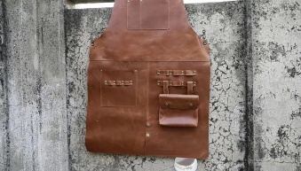
A leather work apron is a layer of material worn to protect the clothing underneath it. It is usually made from leather and generally covers just the front of the person wearing it. A loop goes over the head and secures it behind the neck. A second securing tie goes around the waist.
Work aprons help keep dirt and debris from the work being done from getting onto the person doing the work. They can also protect the wearer from tools that might accidentally get dropped while working. For example, an awl rolls off the table and falls onto their lap. Where a sharply pointed awl might scratch, the apron would provide a layer of protection.
Leather work aprons are available in various sizes, materials, qualities, and finishes. While denim and canvas are options, leather is usually most popular for the look and the material’s function.
Some leather aprons also feature various pockets, offering places to hold frequently accessed tools, pencils, or rulers. While not an essential tool to have when starting out, a leather apron can be a helpful addition as you become more familiar with leather working and develop preferences for working style and tool storage. And they look really, really cool. 🙂

